Village of Surfside Beach
1304 Monument Drive
Surfside Beach, TX 77541
NOTICE OF POSSIBLE QUORUM

NOTICE IS HEREBY GIVEN that a potential quorum of the Village of Surfside Beach City Council and members of various City Boards may be present at the following upcoming
1 . EVENT: City Council and Board Member Retreat
- DATE: Monday, June 01, 2026
- TIME: 10:00 AM to 3:00 PM
- LOCATION: Stahlman Park, 2211 Bluewater Highway, Surfside Beach, Texas 77541
This event is a social and strategic training intended for team building, general discussions, and long-range planning workshops.
While a majority of the City Council or city board members may be in attendance at the same time, this is not an official voting meeting of the City Council or any individual board. No formal city business will be transacted, no official deliberations will take place, and no final action, votes, or binding agreements will be made by the governing body. This notice is being posted out of an abundance of caution and in strict compliance with the transparency guidelines of the Texas Open Meetings Act, Texas Government Code Chapter 551.

CERTIFICATION OF POSTING
I hereby certify that a true and correct copy of the above and foregoing "Notice of Meeting" was posted on the front bulletin board and digital posting areas of the City Hall of the Village of Surfside Beach, Texas, in accordance with the Texas Open Meetings Act, on Tuesday, May 26, 2026, at or before 4:30 P.M., representing three full business days of notice prior to the date of the meeting.
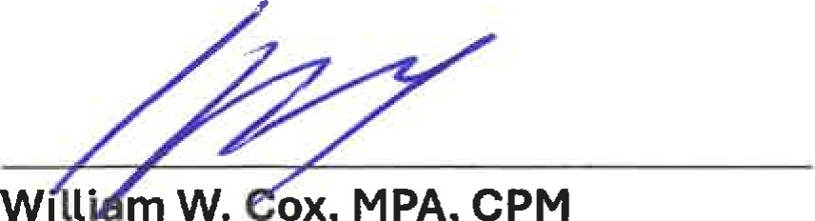
Interim City Secretary / City Administrator

